CSIT314 Software Development Methodologies - Group Project

Sprint 2 - US11: Suspend user account
Interior Design Platform - User Admin
All diagrams were drawn in draw.io. Open "US11 Suspend user account.drawio" in this folder to edit them - each diagram is its own page in that file. The exported images are in the "diagrams" folder.

Assumptions
- The system is the Interior Design Platform from the project specification. Sprint 2 covers the User Admin's search user profiles story (US7) and managing user accounts (US8 - US12).
- A user account is one person's login. It has a username, password, full name, email, phone, the user profile (group) it belongs to, a status (Active or Suspended) and the date it was created. Every account belongs to exactly one user profile and gets that profile's permissions.
- We follow B-C-E: the actor only talks to the boundary (page), the boundary only talks to the controller, and the controller works with the entity classes. There is one controller per use case.
- Simple input checks (empty fields) are done in the boundary. Business rules (e.g. unique usernames, active profile) are done in the controller. Entity classes read and write the database.
- Suspending only changes the account's status to Suspended. Nothing is deleted.
- Log in (US1) checks the account's status (isActive), so this is what stops the user from logging in. Other accounts in the same user profile are not affected.
- The User Admin can't suspend their own account, otherwise they could lock themselves out. The page gets the logged-in admin's userId from the session and passes it to the controller as adminUserId.
- An account that is already suspended can't be suspended again. Making an account active again is not part of this sprint.

1. User story
Story ID | US11
User story | As a user admin, I want to suspend a user account so that the user cannot log in.
Actor | User Admin
Priority | Medium
Story points (estimate) | 3
Acceptance criteria | 1. Given I am viewing an active account that isn't my own, there is a "Suspend" button.  2. Given I click "Suspend", then a confirmation box tells me which account will be suspended and that the user won't be able to log in.  3. Given I confirm, then the status changes to "Suspended" and I see "User account suspended successfully".  4. Given an account is suspended, when that user tries to log in, then they can't (they get the login error).  5. Other users can still log in, and no account is deleted.  6. Given I click "Cancel" in the confirmation box, then nothing changes.  7. I can't suspend an account that is already suspended, or my own account.
Tasks | T11.1 Write the use case description and draw the use case diagram  T11.2 Draw the B-C-E class diagram and the sequence diagram  T11.3 Draw the wireframes for the Suspend button, the confirmation box, the suspended account and the blocked login  T11.4 Write the unit tests first (TDD) for UserAccount.suspendUserAccount() and SuspendUserAccountController  T11.5 Code UserAccount.suspendUserAccount()  T11.6 Code SuspendUserAccountController (already suspended / own account checks)  T11.7 Code SuspendUserAccountPage: Suspend button, confirmation box and messages  T11.8 Check that LoginController (US1) refuses suspended accounts  T11.9 Run the test cases, fix bugs and push to the repo so the CI pipeline runs the unit tests

2. Use case diagram
The user story becomes one use case, UC11 Suspend user account. The User Admin is the only actor.
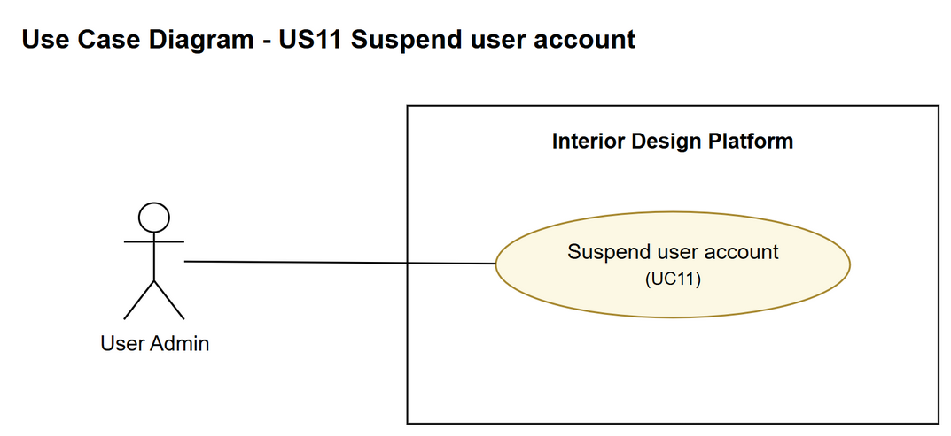
Figure 1: Use case diagram for US11 Suspend user account

3. Use case description
Use case | UC11 Suspend user account
Actor | User Admin
Brief description | The User Admin suspends one user account so that the user can't log in. Nothing is deleted.
User story | US11: As a user admin, I want to suspend a user account so that the user cannot log in.
Preconditions | The User Admin is logged in (UC1).  The User Admin is viewing an active user account that is not their own (UC9).
Trigger | The User Admin clicks "Suspend" on the account's details page.
Basic flow | 1. The User Admin clicks "Suspend".  2. The system asks the User Admin to confirm, saying which account will be suspended and that the user won't be able to log in.  3. The User Admin clicks "Suspend" to confirm.  4. The system checks that the account exists, is active and is not the User Admin's own account.  5. The system changes the account's status to "Suspended".  6. The system shows "User account suspended successfully" and the account with status Suspended.
Alternative flows | 3a. The User Admin clicks "Cancel": the confirmation box closes and nothing changes.  4a. The account is already suspended, or it is the User Admin's own account: the system shows "This user account cannot be suspended" and nothing changes. (Normally the Suspend button isn't even shown in these cases.)
Postconditions | The user account's status is "Suspended".  The user can no longer log in (UC1).  No user account is deleted.

4. Wireframes
The wireframes were drawn in draw.io. They are low-fidelity: they show the layout and the flow, not the final colours. The orange numbers match the notes under each screen.

4a - Suspend button
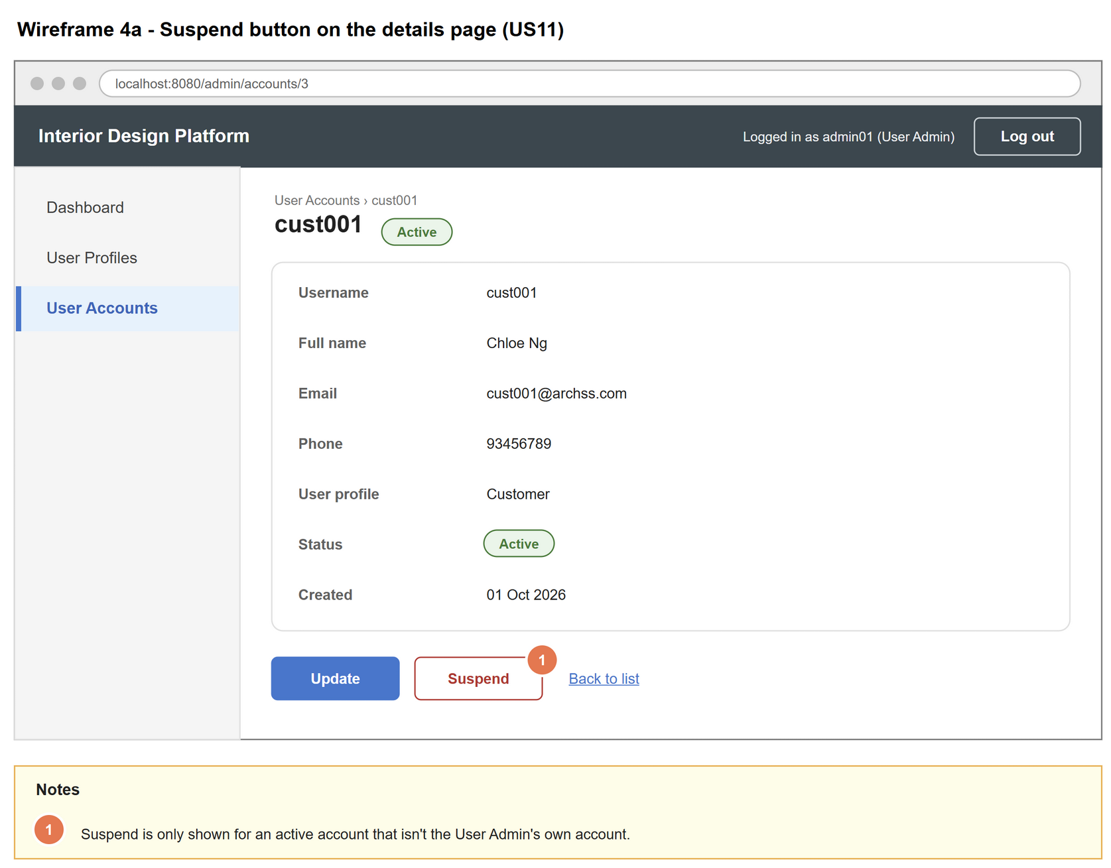
Figure 2: Wireframe 4a - Suspend button (US11)

4b - Confirm suspend
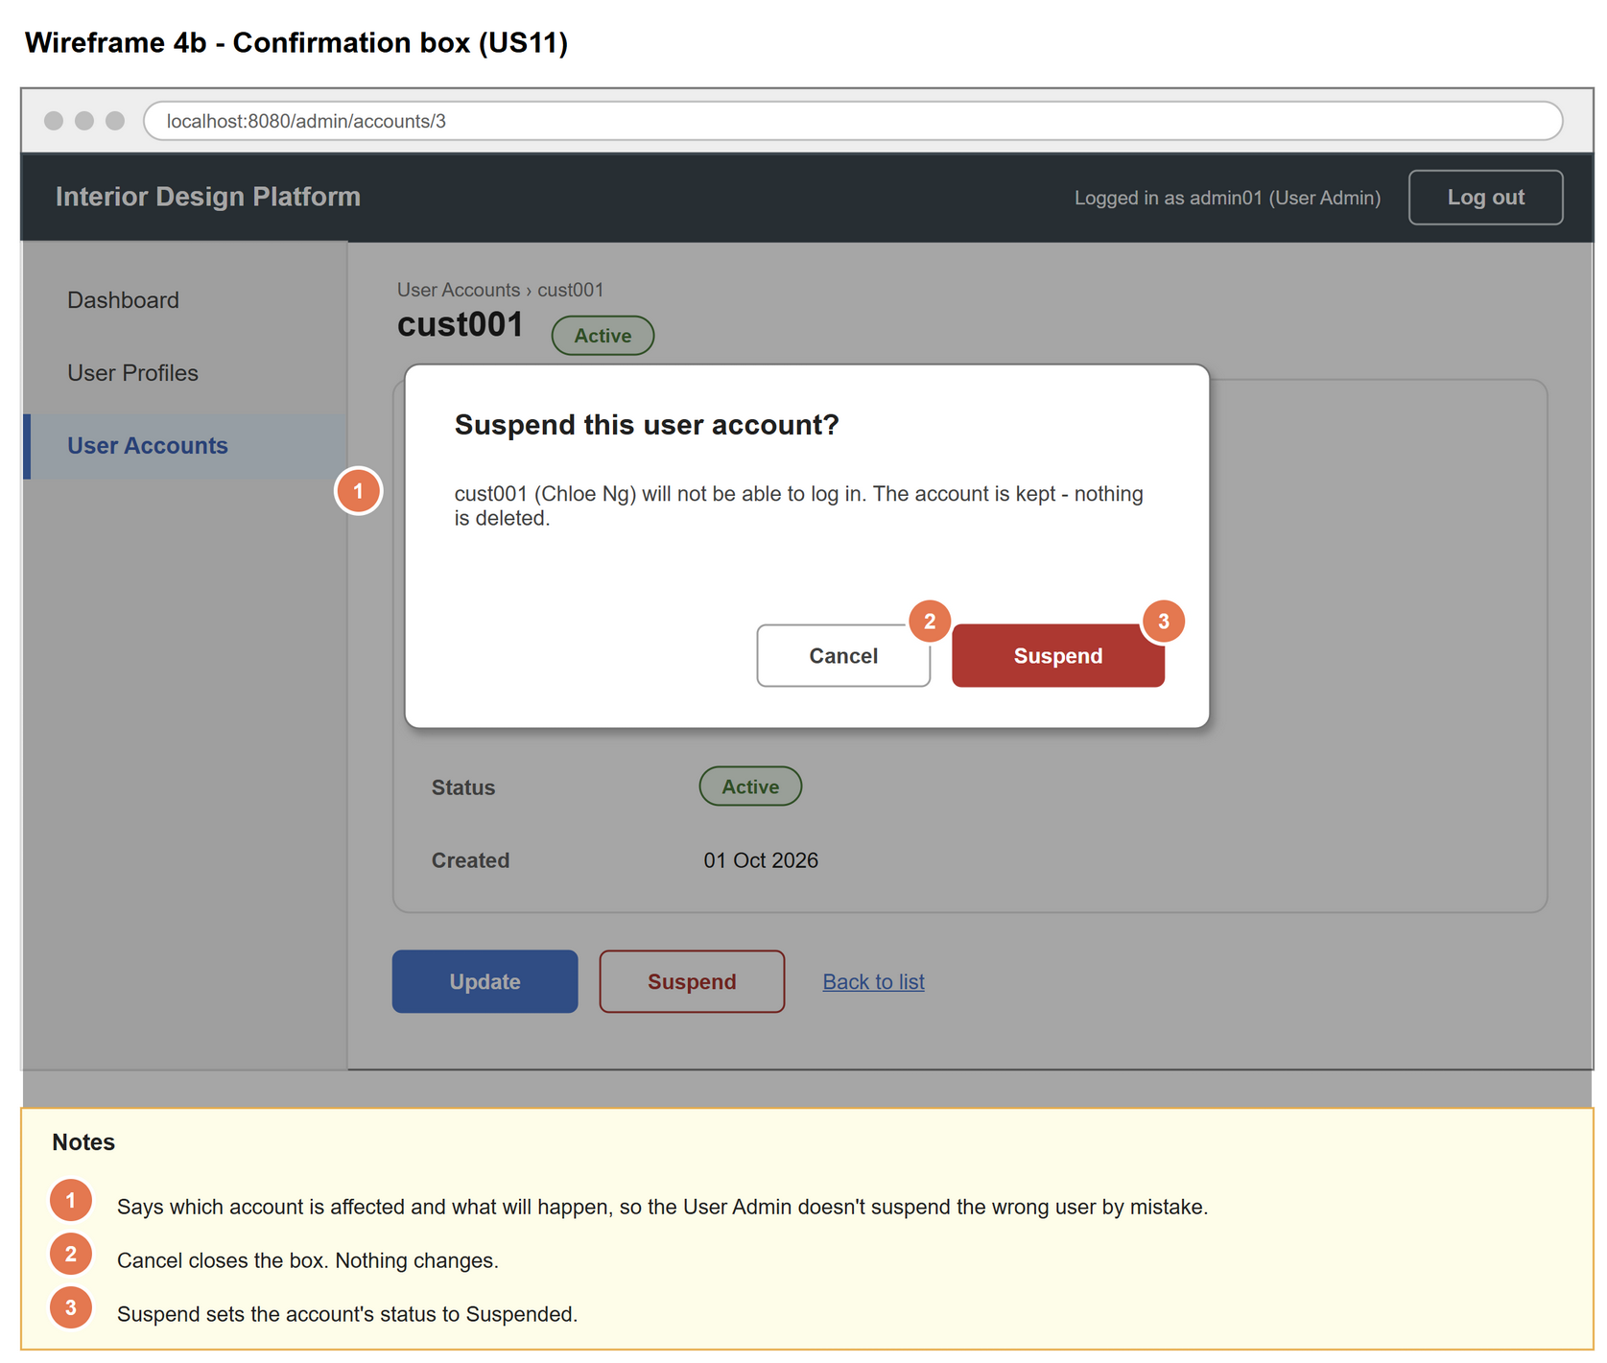
Figure 3: Wireframe 4b - Confirm suspend (US11)

4c - Account suspended
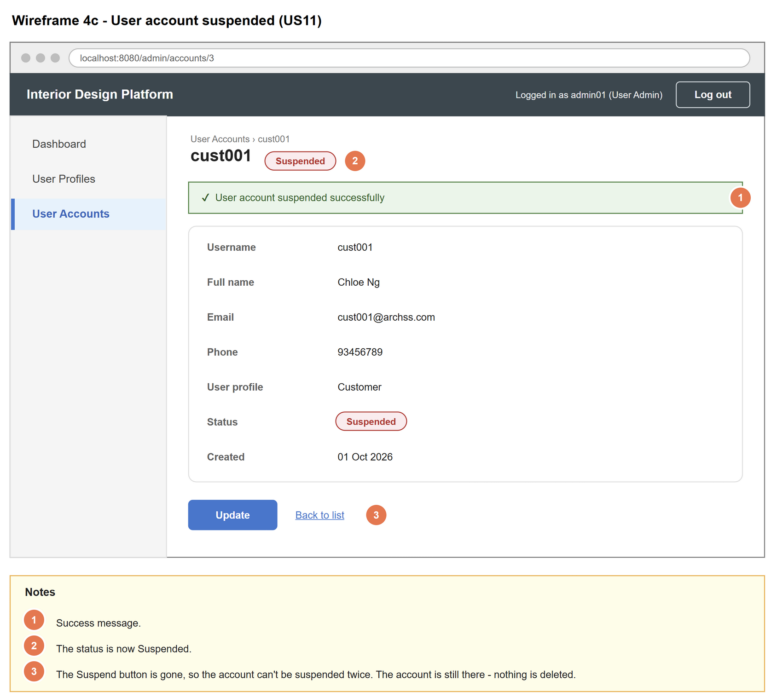
Figure 4: Wireframe 4c - Account suspended (US11)

4d - Blocked login
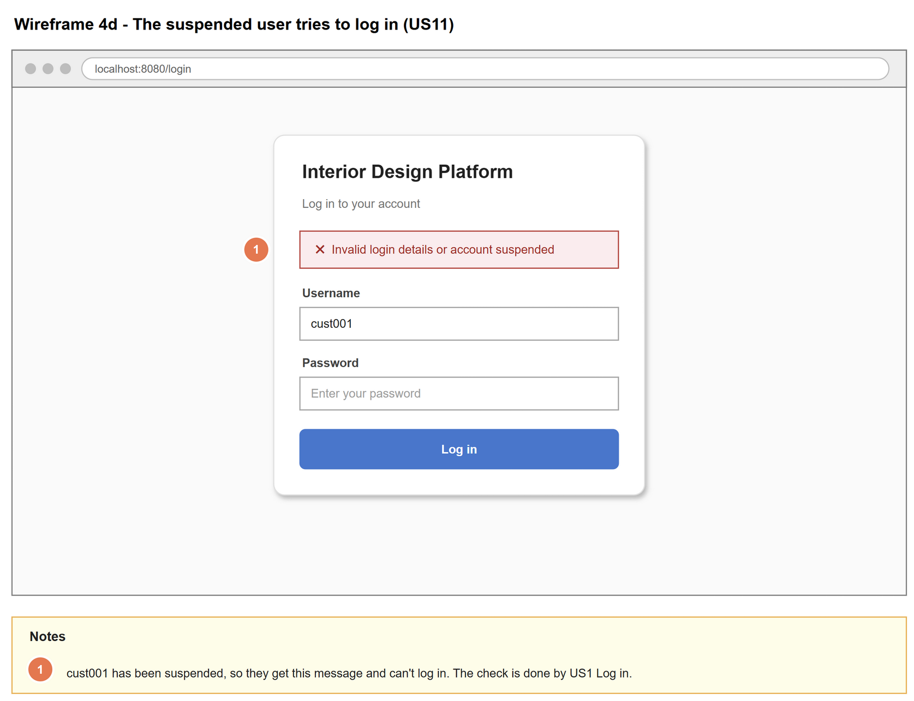
Figure 5: Wireframe 4d - Blocked login (US11)

5. B-C-E class diagram
The solid line means the boundary calls the controller. The dashed line means the controller uses the entity class. Only the operations needed for this use case are shown.
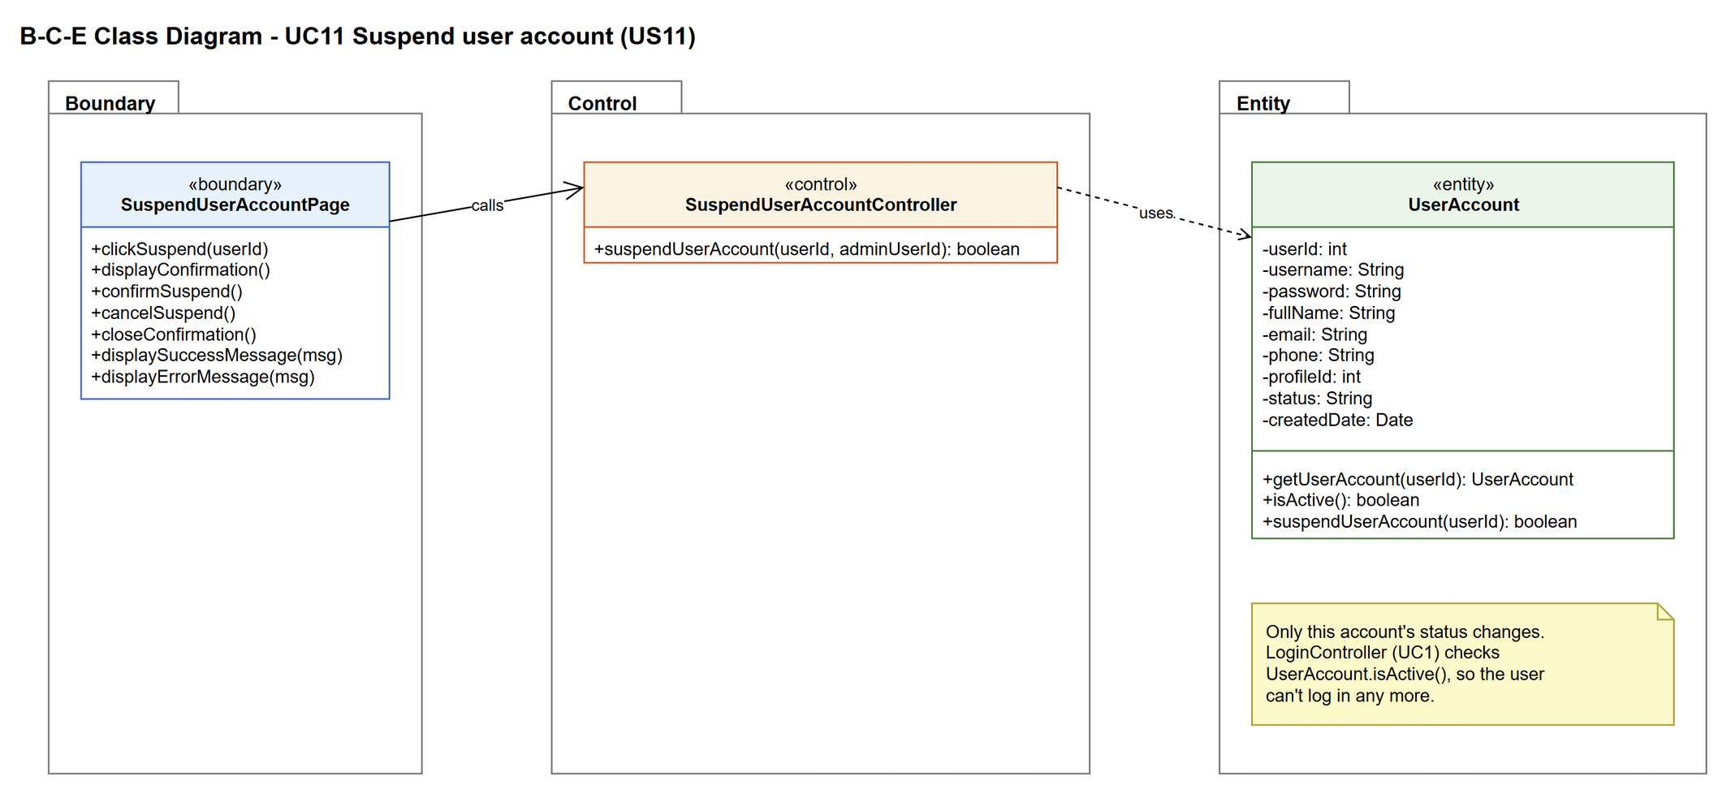
Figure 6: B-C-E class diagram for US11 Suspend user account
Layer | Class | What it does
Boundary | SuspendUserAccountPage | The Suspend button and the confirmation box on the account details page. Passes the userId and the logged-in admin's userId to the controller and shows the result.
Control | SuspendUserAccountController | Controller for UC11. Applies the business rules: the account must be active and must not be the admin's own account. Then asks UserAccount to suspend it.
Entity | UserAccount | suspendUserAccount() changes the status to Suspended. isActive() is also what Log in uses to refuse suspended users.

6. Sequence diagram
The sequence diagram follows UC11. After the confirmation box is shown (step 2), the outer alt has the two choices: confirm (step 3) or cancel (alternative flow 3a). When confirmed, the controller gets the account and checks it is active and not the admin's own account (step 4). Only then is the status changed (opt box, step 5). The inner alt shows the success message (step 6) or the error message (alternative flow 4a).
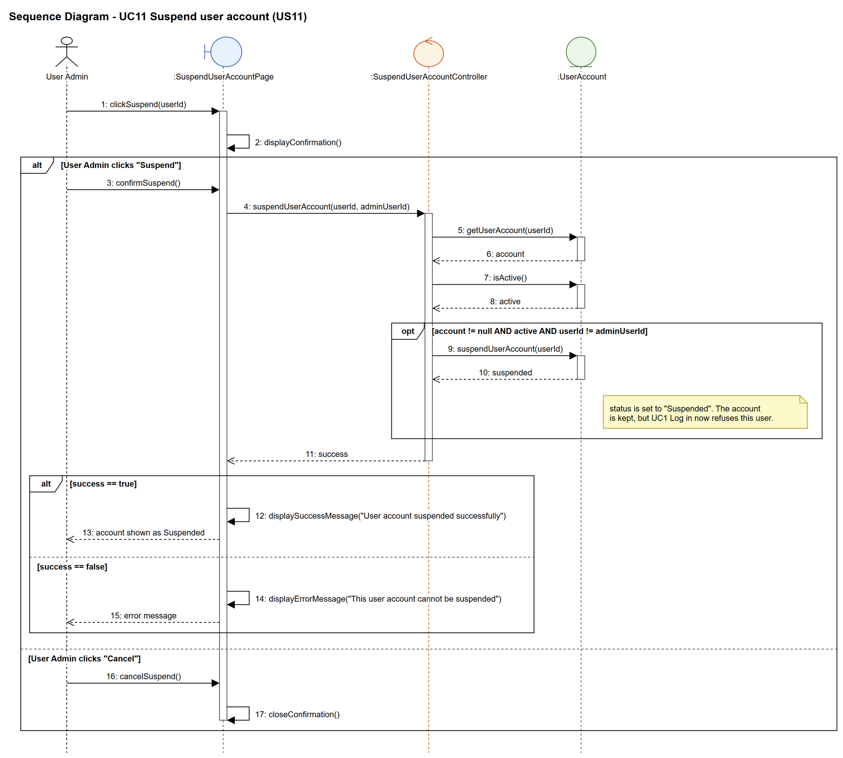
Figure 7: Sequence diagram for UC11 Suspend user account

7. Test cases
Test data used below (same as database/seedData.py): user profiles User Admin (id 1), Interior Designer (id 2), Customer (id 3) and Platform Manager (id 4), all Active. User accounts admin01 / Admin@123 (id 1, User Admin, Active), admin02 / Admin@123 (id 2, User Admin, Suspended) and cust001 / Cust@123 (id 3, Customer, Active).

7a. System test cases (black box)
Equivalence partitioning and boundary value analysis were used to pick the test data. Fill in "Actual result" and "Pass/Fail" after running each test.
Test ID | Scenario | Prerequisites | Test steps | Test data | Expected result | Actual result | Pass / Fail
TC11.1 | Suspend an active account | Logged in as admin01. cust001 is Active. | 1. View cust001  2. Click "Suspend"  3. Click "Suspend" in the confirmation box | cust001 | "User account suspended successfully". Status is Suspended. The Suspend button is no longer shown.
TC11.2 | The suspended user can't log in | TC11.1 done. | 1. Log out  2. Log in as cust001 | cust001 / Cust@123 | "Invalid login details or account suspended". Not logged in.
TC11.3 | Other users are not affected | TC11.1 done. | 1. Log in as admin01 | admin01 / Admin@123 | admin01 logs in normally.
TC11.4 | Nothing is deleted | TC11.1 done. | 1. Open the User Accounts list | cust001 | cust001 is still in the list (Suspended).
TC11.5 | Cancel the suspend | cust001 is Active. | 1. View cust001  2. Click "Suspend"  3. Click "Cancel" | cust001 | The box closes. Status is still Active.
TC11.6 | Confirmation names the account | cust001 is Active. | 1. View cust001  2. Click "Suspend" | cust001 | The box says cust001 (Chloe Ng) will not be able to log in.
TC11.7 | Already suspended account | Logged in as admin01. | 1. View admin02 | admin02 | No Suspend button is shown.
TC11.8 | Own account | Logged in as admin01. | 1. View admin01 | admin01 | No Suspend button is shown. admin01 stays Active.

7b. Unit test cases (for TDD)
These are written before the code (test-driven development) and run automatically in the CI pipeline. They cover normal inputs, abnormal inputs and boundary values.
Test ID | Class and method | Input / setup | Expected output | Type | Pass / Fail
UT11.1 | SuspendUserAccountController.suspendUserAccount() | 3, 1 | Returns true. getUserAccount(3) has status "Suspended". | Normal
UT11.2 | SuspendUserAccountController.suspendUserAccount() | 2, 1 (admin02 already Suspended) | Returns false | Abnormal
UT11.3 | SuspendUserAccountController.suspendUserAccount() | 1, 1 (admin's own account) | Returns false. admin01 is still Active. | Abnormal
UT11.4 | SuspendUserAccountController.suspendUserAccount() | 9999, 1 | Returns false (no error thrown) | Abnormal
UT11.5 | UserAccount.isActive() | cust001 after UT11.1 | Returns false | Normal
UT11.6 | LoginController.login() | "cust001", "Cust@123" after UT11.1 | Returns null (can't log in) | Normal
UT11.7 | UserAccount.suspendUserAccount() | 3 | The number of rows in user_account is the same before and after | Normal

